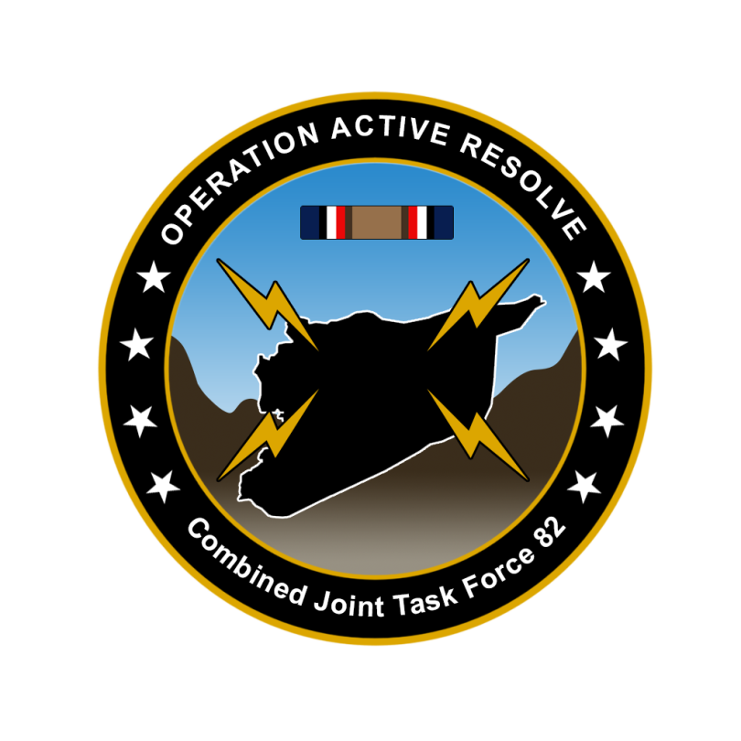

CJTF-82 FRIENDLY UPDATE

D+4

# SITUATION

## General situation

July 1st, 2011, Syria conducted a surprise attack against Turkey and Israel. After a week of intense fighting the Syrian forces have in Turkey seized control of the area of Iskendrun. In Israel Syrian forces have seized control of the Golan Heights. 10th of July, UN Security Council released resolution 3263 which calls the Syrian aggression unlawful, and that Syrian forces should be returned to its position before 1st of July 2011. 15th of July, a coalition of the willing is formed to support Turkey and Israel. The military coalition have been given the name Combined Joint Task Force 82.

1st of August, UN Security Council resolution 3274 was released. This resolution gave Syria a deadline of 31st of August 2011 to comply with UNSCR 3263, and the resolution empowers states to use all necessary means to force Syria out of Turkey and Israel after the deadline.

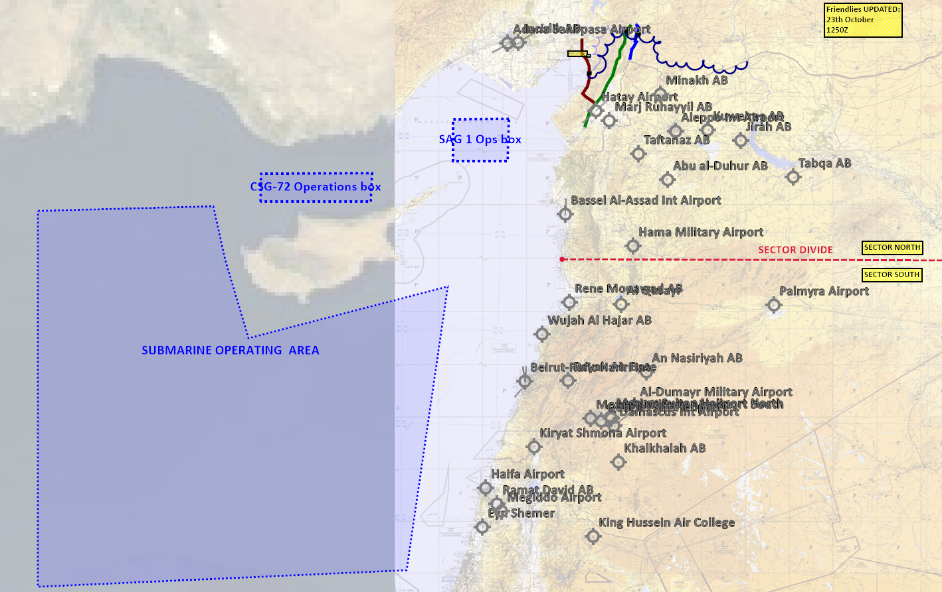

## Friendly situation

### Land Component Command (LCC)

Land Component Command consists of 2 Corps: IV Corps and III Corps.

IV Corps is US led and are currently building combat power in Turkey and will be used to support Turkish forces to expel Syrian forces in Turkey.

III Corps is led by the United Kingdom, and is building up combat power in Israel and will be used to support Israeli forces to expel Syrian forces in Israel.

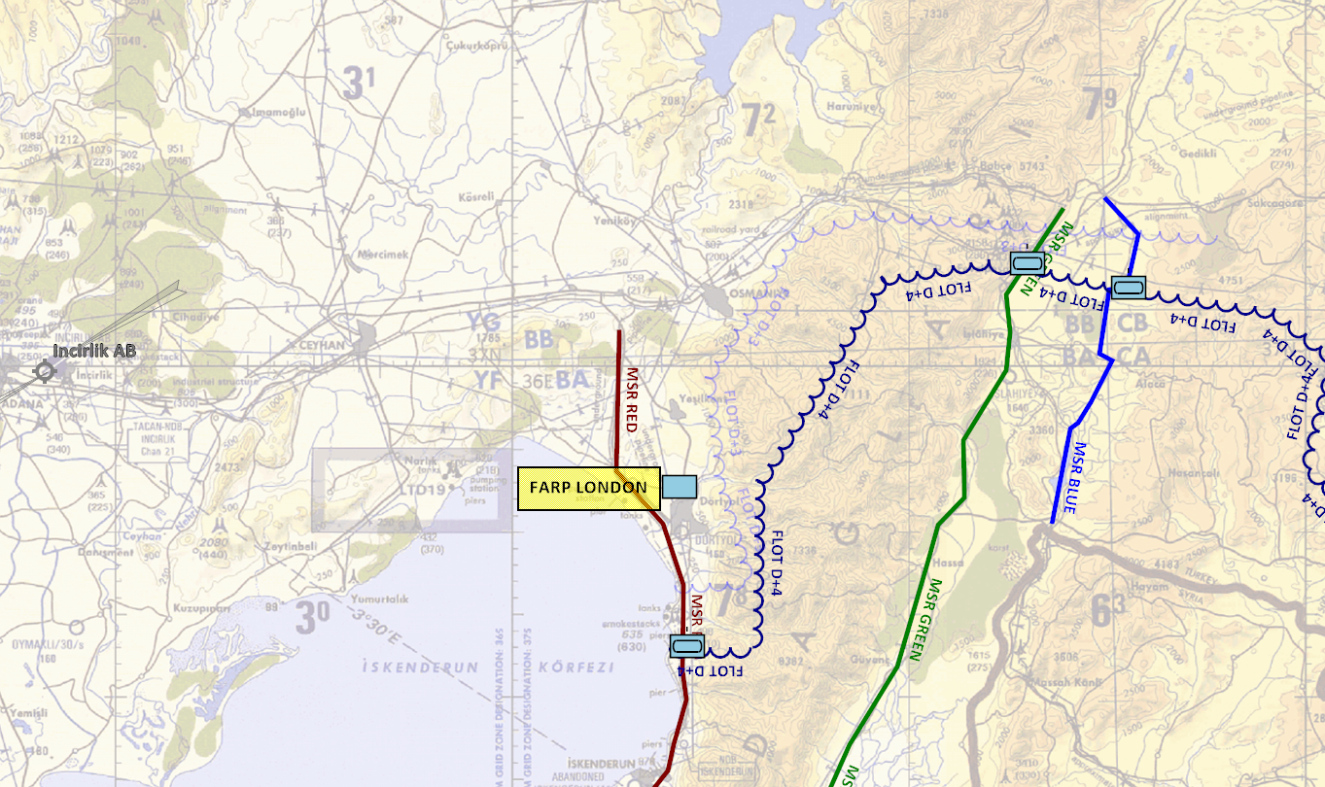

### Maritime Component Command (MCC)

Maritime Component Command consist of

* Carrier Strike Group-72 (CSG-72): USS Abraham Lincoln + 1x Arleigh Burke
* Surface Action Group 1 (SAG-1): 1x Oliver Hazzard Perry + 1x Ticondoroga

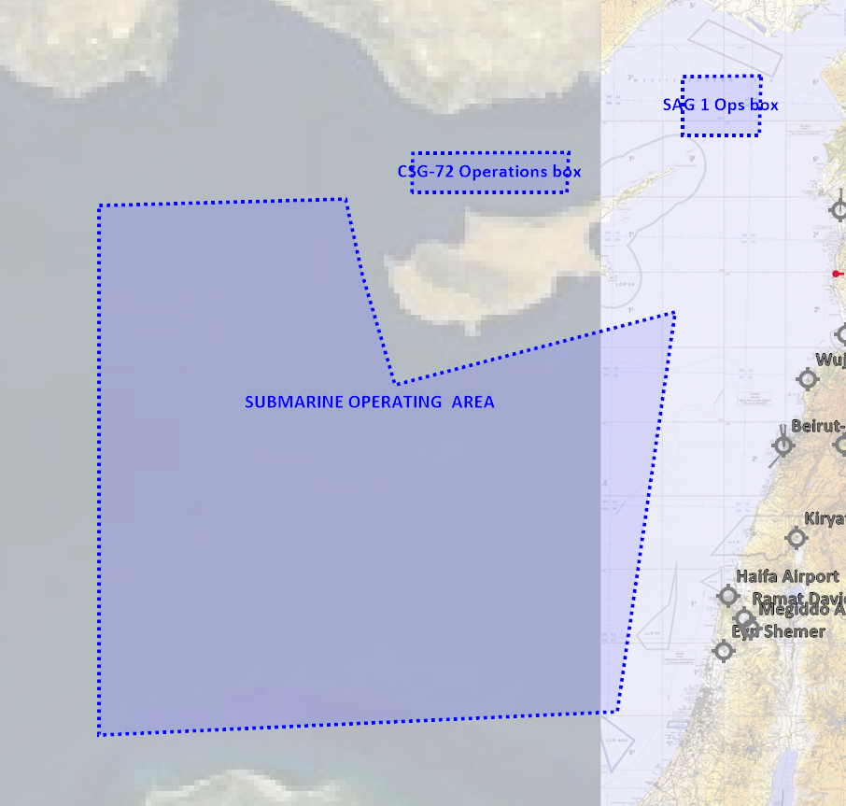

### Joint Force Air Component Command (JFACC)

Joint Force Air Component Command consists of the 132nd Virtual Wing split on Incirlick and Ramat David Airbase. E-3 and Tanker squadrons have also arrived in theater and are getting ready to support operations.

### Special Operations Component Command (SOCC)

Special Operations Component Command consists of 4 Special Operations Task Groups based both in Israel and Turkey.